Evan Couval

Professor Ryan

CS-110-B

13 December, 2020

Final Project Report

Section 1

My program provides the user with a form of technical analysis on the stock of their choice. It first asks for their desired stock in the form of the ticker. Next, it asks the user for a timeframe, with the option to use all available data from the stock’s listing or the data from a custom timeframe. It uses this information to pull the specified data from Yahoo Finance’s database using the yfinance library. It then runs the data through a function that calculates the cumulative returns for each day’s normal trading hours (9:30am - 4:00pm) and plots it against the cumulative returns for after hours and pre-market. In doing so, it exposes a major market anomaly in the SPY and many other stocks/indices. This market anomaly is the trend for after hours and premarket gains to be much greater than the normal trading hours day’s gains. Two different inputs and outputs are shown below.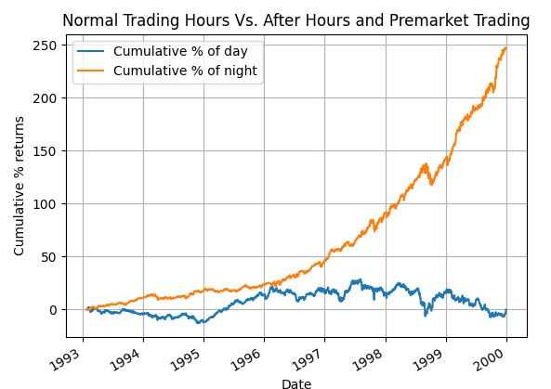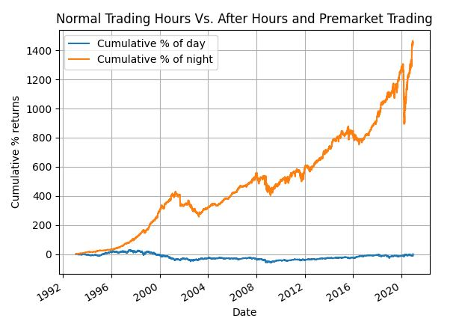

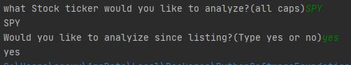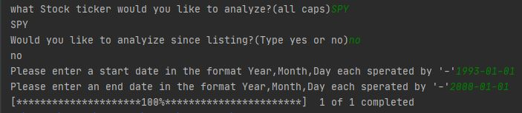

Section 2

My target audience would be anyone interested in technical analysis of stocks or anyone interested in finding both short and long term trends in the markets. One Could use the algorithm I created as a base to make even more unique tools.

Section 3

My program was built in a very simple structure to retrieve data, manipulate data, and finally visualize the data. The most used type of data in this function was by far the dataframe. Using dataframes made it much easier to mold the massive amounts of data(sometimes over 20,000 data points!) that I planned on working with. The results I garnered would have been nearly impossible to achieve with a simple list. For example some data frame operations I used included multiplying and dividing entire columns together. I was able to do this with the help of the Pandas library, which offers data structures and operations for manipulating numerical tables and time series in Python. Also, the yfinance library made retrieving custom up to date yahoo finance data very simple.

Section 4

I had two major challenges in writing this program; learning how to operate the pandas library and more specifically creating an algorithm for my program. Learning how to use data frames became easier as I constructed my program, but creating my algorithm was a whole different beast. I spent hours of trial and error for just about 12 lines of code. First I had to split the desired stock into four separate columns -- the normal open close, and the after hours open and after hours close. I did this by shifting the normal open column down a row to get the AH close and simply making a copy of the original close to be the AH open. Next I had to come up with an equation to calculate the cumulative returns. I developed this by creating a test data frame with pen and paper and manipulating the simple numbers to achieve a desired outcome and algorithm. The hard part was taking this knowledge and turning it to code. I first had to initialize the current price value with the first open. I then used a for loop to construct the current price dataframe value by value. The for loop iterates through the values in the ‘open’ column. I calculated the day’s change by multiplying the current price by the iterated rate of return. Next, I added the day’s change to the current price of the day to get the variable I called totalmoneyday. I then used the rate of return equation again, except with the variables totalmoneyday and initialpriceday, being final and initial respectively to get the percent returns. I then set totalmoneyday to its iteration’s row in the dataframe column ‘net g/l day’. I also set total percent returns of that day to its iteration’s row in the dataframe column ‘% returns day’. These two columns were previously initialized to 0 before the for loop. The current priceofday variable was then set equal to totalmoneyday to be reused for the next loop iteration. I repeated this process with slight name and column tweaks for the cumulative returns of the night.

Section 5

One of the improvements yet to be made to this program would be the ability to compare the cumulative returns of the night and day for two or more stocks. Furthermore, one could develop a function that plots which months had the highest returns for either the night or day over a stock's inception.